Firstly, appologies for the lack of newsletters for the first part of 2017, but with extremly bad weather and several washouts at the beginning of the year, my work commitments oveseas, plus a hunting trip to Victoria for a week (–: that’s pretty much 6 months gone – where did it go?
I hope this finds everyone well, and looking forward to the back end of 2017, with some great up-coming events programed for the remainder of the year. I am still looking for interesting stories for the news letter – so please put your fingers to the key board, send me a draft with photos and I will use as part of the club monthly story, as I can only do so much on my own, and it is nice to see what other members are up to in the archery world!.
Send to: Barrie – hombrobaz@gmail.com

UPCOMING CLUB EVENTS
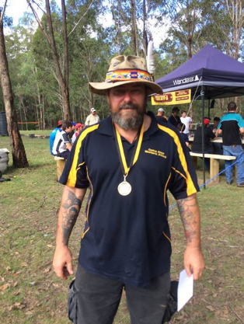
June has seen a working bee and a club comp conducted during the month with a good turn out despite a lot of members attending competitions around the State. A number of Moonterra members have been competing and doing very well, and a big congratulations to all. Of note JB attend the State Titles in QLD and is currently rated 3rd in the Bowhunter Class in Australia.
An up-coming event for everyone – Club Annual AGM! The AGM will be held on the 23 Jul 17 at Moonterra, and a reminder to all that Lez will put on breakfast for everyone that turns up. An important time of the year, and there are a few positions becoming vacant on the committee – and it is important to attend to nominate and or vote and have your say! There will be agenda items too, so come and see what is being presented as it is your club afterall. Please, even i f you can only attend for the meeting, that will be fantastic.
CLUB PRESIDENT COMMENTS
I would like to take this opportunity to thank everyone for their support and the continued progression of the club facilities over the last 6 months. There has been some great additions, new bails and the ranges are in good order. A great effort.
I would also like to let everyone in the club to know, that I WILL NOT be standing for president after the end of this term. Over the past 5 years I believe that we as the committee have steered the club in a sound direction & have achieved quite a lot of improvements along the way, and now it is time for someone else to take over the helm.
If you think that you would like to take on the role, be at the AGM, and stand for the position.

Cheers Pete Daniel

JUNE CLUB POINT SCORE
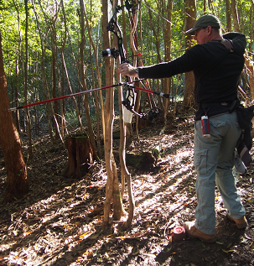
As previously mentioned, despite numbers being down with members away on competitions around the State, there has been a reasonable roll up for the Club Point Score and the working bee. The June point score was conducted on the yellow route, which was prepared and cleaned on the working bee the week before. The Yellow route and the Green route were re-marked and the firing points are much clearer with well defined red, green and yellow colours.
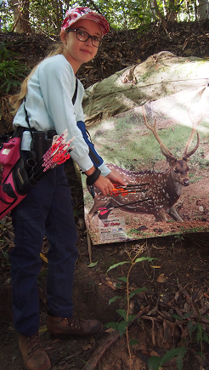
The targets were set early and 2 groups did the rounds and pretty much everyone scored 700 plus for their rounds, which is a great result. Young Zara is an up and coming cub, scoring 728 for the 2 rounds and shooting consistantly well – great effort.
We could not have asked for better weather and was a little cool down in the river beds. Most of the the groups did their rounds in the early morning, and it is amazing the difference in shooting in winter as to summer. With the sun low on the horizon during winter, the shadow across the target and the bright sunlight piercing the canopy, made some shots very difficult. A challanging day for all those who attempted the rounds.
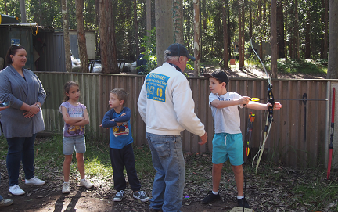
I must point out that besides the club members attending the point score, it is wonderful to see families coming to the club to test their skill and meet club members. A special thanks to Bill and Lez who allways step in to make people welcome and assist them with an intro into archery – much appreciated.
If you missed the June Point score, we hope to see you at the next one in Jul, noting also that Jul is an important period for the club with the club AGM to be held on the 23 Jul 17.
____________________________________
MONTHLY STORY
MOONTERRA Members – Winning Medals!
The year started out wet and miserable with many weekends washed out and or cancelled due to bushfires and put a damper (pardon the pun) on monthly planned activities. However, many club members soldiered on and were committed to several of the State competitions, and as mentioned JB now holds 3rd place in Australia.
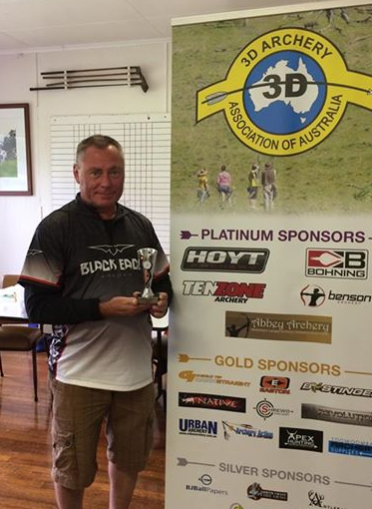
I would like to mention some of the other dedicated members that have also competed, scored well and won medals, and I speak of, Darren Ross and the Cheetham family (Steve, Ross and Amber) and the already mentioned John Boy, congratulations to you all.
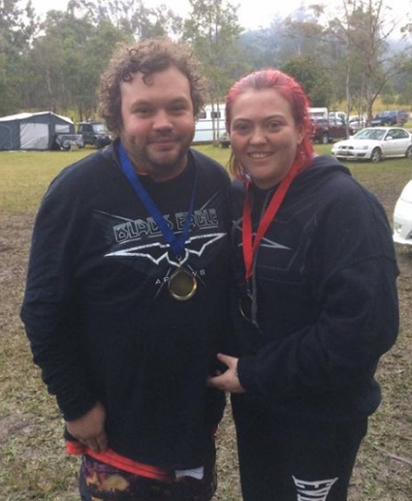
They have attended the Lake Macquarie 3D Classic, and the 3 D State Titles in Gloucester NSW with great results in their Divisions. JB achieved 2nd, Darren 2nd and Ross and Amber achieving 2nd and 3rd respectfully. Not only have they represented themselves extremely well, but have also attended many of the club activities as well. It was not that long ago I was on the Red Route with my group and the Cheetham’s were in the group in front, noticing Amber pulling a shaft from a nearby sapling, with lots of banter between groups and arrow placement. Amber has improved in leaps and bounds and I think it would be a challenge to keep up with her on a round these days as she has improved so much. A huge credit to her and the support from Ross all the way.
I have attended a 3 D comp myself, (Norfolk Island) and I can tell you they are challenging, a lot of fun and worth the effort. You get to share the experience with others that enjoy the sport, learn from others more experienced, and in the Cheetham family’s case get to share it with their partners, family and friends. If you get the opportunity, regardless of your level have a go and if you want some information on the subject I am sure Darren, Steve, Ross and Amber would be happy to give you some tips and advice.
So to all Moonterra Archers who have attended other archer events, competitions and gained medals, a warm and hearty congratulations, well done and looking forward to hearing about it at the next club meet.
Barrie Rhodes

ADVERTISEMENT
Full Draw Archery Supplies – Call Ralph on 0413-054-722 for all your archery equipment advice and support.
Archery Tag – Call Andrew for a booking/ details on 02 4389 2606 or mobile: 0419 486 034 for bookings – A great alternative for kids/ buck parties and all ages.
NOTICE
CLUB AGM – Club AGM 23 Jul 17, held at Moonterra Club House, with breakfast provided by Lez on the day – Time TBC. Please come and have your say!

