Welcome to this months October 2016 edition of Moonterra Archery Club Monthly Chat. Intent is to provide everyone with a monthly review, up-coming events and stories from our members to share with all, particularly any hunts, competitions and photos from events that we can share and keep you informed.

I will look at also up-dating the Web Page so that the same details can be shared on line if you are web based, rather than email based as preference.

UPCOMING CLUB EVENTS
Sun 16 Oct 2016 – Range Clean Up
Starts at 09:00 (9am) and concludes around 12:00 (lunch time) and your support is greatly appreciated in preparing the range for the upcoming Club Point Score. Come along, support your club and meet Lez for one of his famous ‘burgers’.
Sun 23 Oct 2016 – Club Point Score
Starts at 09:00 and everyone is encouraged to attend, don’t forget the score goes toward the annual trophy competition. The point score is being conducted on the Green Route, a challenging route on any day and all are welcome.
CLUB PRESIDENT COMMENTS
I have been to the range lately and have noticed a lot of rubbish left behind at the range. It is everyones responsibility to keep the range clean and tidy, as we are lucky to have the area for use, and the last thing we need is for the State Forest Autority to see the area missused, and we could forfeit the facility which clearly could have been avoided by putting rubbish in the bins provided or taking it with you when you leave.
DO THE RIGHT THING
DID YOU KNOW?
Not sure if everyone is aware – maybe youhave heard about it? The World Meet is being held in Australia this year at Wagga Wagga and John Boy (JB) has qualified for the event and will represent himself and the club at the world meet.
Congratulations JB – and the best of luck to you and your PSE.

MONTHLY STORY
Every month we hope to provide a story from members for the Chat, to keep you informed and hopefully interested in getting out and knocking that arrow.
Here is one from Barrie Rhodes on a trip to Norfolk Island.

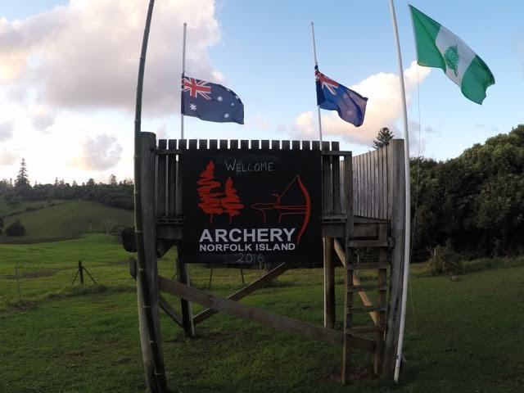
Norfolk Island 3D Competition – 2016
Every year “Archery Norfolk Island” put on a 3D archery competition for all ages, classes and competitors. The 3D targets are varied, from the traditional deer, pigs and turkeys, with a mix of dinosaurs, skunks, armadillos, bear, lion and leopards to name a few, spread amongst open field and wooded ranges across the magnificent landscape of Norfolk Island. I saw the advertisement in the Archery Action magazine, and as one of our members had been the year before and raved about the competition, location and event. ….What the hell I thought I would give it a go.
This year there were 76 competitors, but according to the Norfolk Island Tourist Bureau, there were well over a 100 visitors to Norfolk Island for the competition, like me, included archers with partners. One of the things that attracted me to the competition was that the competition is synchronised with the Norfolk Island Tourist Bureau so there is plenty of time to do the tourist thing as well as competing in the archery competition. It is (if you are from NSW), a Friday to Friday (other states and NZ vary by 1 to 2 days) event with the actual competition running Monday and Tuesday morning, all day Wednesday and Thursday is a fun day for both traditionalists and compound archers.
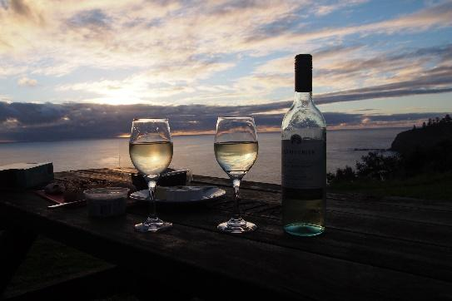
Because the competition is structured as such there is plenty of time to explore Norfolk Island, and immerse yourself in the history of the Island and the Mutiny on the Bounty story and life as a convict, and best of all – relax and enjoy the island with your partner and family. Registration is on the Sunday night and is a great opportunity to break the ice and meet people from all over Australia and New Zealand over an ale and a “Fish Fry”. If you do decide to go next year, I can certainly recommend visiting the Cyclorama that provides a true account of the Mutiny on the Bounty. The half day tour is also a great way to get a snap shot of the history of the Island. Our package included a car and we used the information from the half day tour to explore in our own time the places we brushed over on the tour. Best places for coffee is The Olive (main part of town) and the Cyclorama Café called Hilli’s.
The first day of the competition is on the open fields, and the course is set up so that it is not too difficult, yet still provides a challenge with shots across open fields, water courses and up and down hill. The morning brief commenced at 09:00am, but the practice range was open from 07:30am. We were split up each day into groups of four people, with both traditionalists, compound and cubs mixed together, which changed every round, so that you got to meet different people to talk and reflect on the competition and in general 3D archery. Of course there was the constant rivalry between Trads and Wheelies – a term I was not familiar with, but soon got to accept the nomenclature for me and my compound bow. Some of the trads took it very seriously and dressed to the part – Robin Hood would have been Proud.
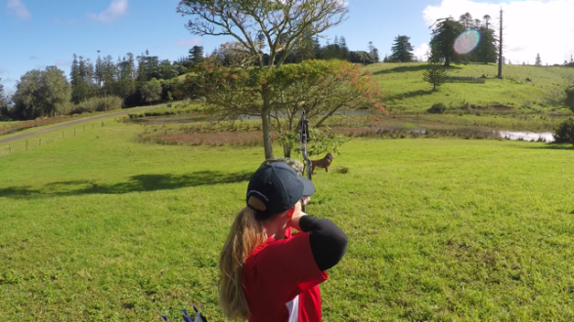
Day 2 started as for day 1, a quick warm up, coffee, a very informative brief, map issued with details of station locations and score cards. The difference on day 2 was that it was in the scrub and a little more challenging. Targets were well placed for shots through vines, scrub, downhill, uphill and into targets that were light and dark, well placed to make you think about judging the distance for the shot. Clearly these positions were set by a hunter, as they were both realistic and challenging. We were mixed into different groups again, but always trads and wheelies together. Because day 1 and 2 were only from morning to lunch time – there was plenty of time to continue the tourist thing around the island with partners and family.
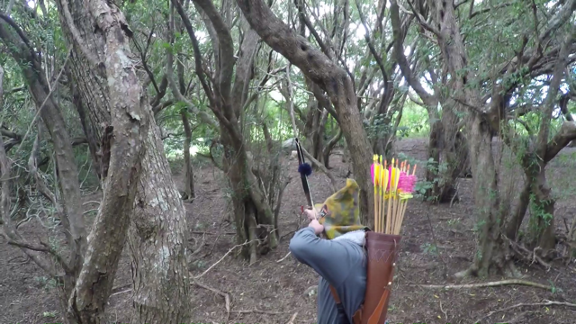
Day 3 was an all-day affair, and even more challenging. Targets were again well placed, and in some cases could only be seen when you were standing on the mark for the shot. The course was also set so that you shot from out in the open into the woods, and visa versa. The weather stayed clear for the morning and some archers were happy with their scores (4 rounds – best of 3 scored) and did not continue in the afternoon, as the weather changed with light showers. Over lunch the organisers dashed out and changed the course layout, and we were placed again into different groups, but the weather came and went and the afternoon shoot was also very challenging with the rolling clouds and odd shower or two, just to make it interesting.
The 4th day was more of a “novelty” event, particularly for the Trads. What was a hoot was the “horseback event” – a horse saddle on a large vine that provided sufficient movement (human induced) on the archer. Hilarious activity, particularly trying to nock the arrow and shoot. The day also consisted of traveling the island to different locations and shooting events at the different properties that were organised by Archery Norfolk Island members. Specifically a large 3D bear, on the cliff top edge with the background - nothing but high cliffs and the sea. So if you missed, and your arrow didn’t fall short into the grass – say good bye to the shaft – Archer Nil – 3D Bear 1.
Presentation night was conducted at the local RSL, food was good (plenty of it) as was the company. Presentations were conducted starting with the cubs (so that parents could get them away early) and progressed at intervals between the 3 course dinner. During the night, there was a background screen displaying all the photos collected by Archery Norfolk Island Members and competitors. A great fun night and a brilliant way to end what was an excellent event.
So if you are after an archery competition that is well organised with a large and varied collection of 3D targets, placed in diverse and challenging environments – then Archery Norfolk Island is for you. If you are looking for a holiday package that suits the whole family, with a 3 D archery competition nestled in the trip, hopefully this article will give you some food for thought. To all the “Trads” that I met, and fellow “wheelies” I shared Archery Norfolk Island 3D competition with, and the members of Archery Norfolk Island thank you for your friendship and the opportunity to share a wonderful experience on Norfolk Island.

Barrie Rhodes

FOR SALE
Items for sale
ADVERTISEMENT
Full Draw Archery Supplies – Call Ralph on 0413-054-722 for all your archery equipment advice and support.
Archery Tag – Call Andrew for a booking/ details on 02 4389 2606 or mobile: 0419 486 034 for bookings – A great alternative for kids/ buck parties and all ages.

